Low Impact Development Plan
(LID Plan)

Project Name:

INSERT Application and/or Tract Number & Lot Number
INSERT Site Address

Prepared for:
Insert Owner/Developer Name-then TAB.
Insert Address 1 then press ENTER to insert Address 2 or TAB to next field.
Insert City, State, ZIP-then TAB.
Insert Telephone-then TAB.

Prepared by:
Insert Consulting/Engineering Firm Name-then TAB.

Insert Address-then TAB.
Insert City, State, ZIP-then TAB.
Insert Telephone-then TAB
INSERT Initial Date Prepared
Revision #1 Date: Insert Date
Revision #2 Date: Insert Date
Revision #3 Date: Insert Date


Low Impact Development Plan Cover Sheet
(MS4 Permit No. CAS004004, Board Order R4-2021-0105)

 | Item | Detail | Page No. Reference
1 | Site Location (address, APN, and/or tract info.)
2 | Estimated Project Construction Timeline | Start:  Completion:
3 | Project Category (verbatim as listed in LID Manual)
4 | Total Project Area (Square Feet)
5 | Total Disturbed Area  (Square Feet)
6 | Pre-Project  Impervious and Pervious Areas | Impervious % Square Feet  Pervious % Square Feet
7 | Post-Project  Impervious and Pervious Areas | Impervious % Square Feet  Pervious % Square Feet
9 | 85th Percentile Rainfall Depth
10 | SWQDV and Storage Capacity per Drainage Management Area(s) (DMA)
  DMA  (name or ID) | SWQDV  (cf) | Storage Capacity (cf)
11 | LID BMPs
  DMA  (name or ID) | BMP Type
12 | Hydromodification | Is this Project exempt from Hydromodification Controls?  Yes No  If Yes, provide exemption description. If No, provide brief description of proposed hydromodification control BMPs.
13 | Alternative Compliance | Was entire SWQDV retained on site and mitigated with LID BMPs? Yes No  Of No, provide brief description of Alternative Compliance pathway and ensure detailed justification and required information is provided in Section 3.
14 | Completed Maintenance Covenant and Operations & Maintenance Plan | Maintenance Covenant Attached? Yes No  If No, provide justification.  Operations & Maintenance Plan Attached? Yes No  If No, provide justification.

Example Maintenance Covenant
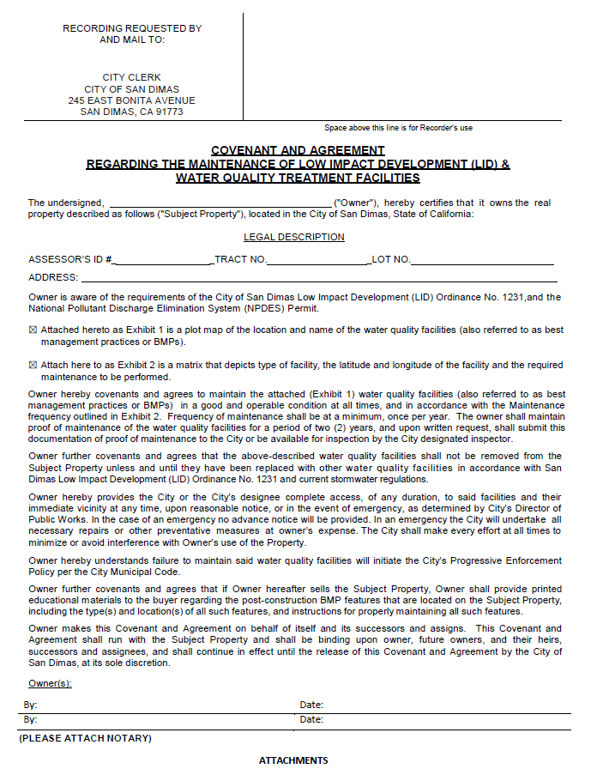

EXHIBIT 1

ASSESSOR’S ID # ______________ TRACT NO. ______________________ LOT NO.____________________________

ADDRESS: _________________________________________________________________________________________

BMP Name/Type | Area Treated | GPS Coordinates (Latitude/Longitude) | Maintenance Frequency | Type of Required Maintenance | Proprietary BMP – Company Maintenance Information



EXHIBIT 2
(SCALED PLOT MAP OF LOCATION OF BMP/WATER QUALITY FACILITY ON PROJECT SITE)

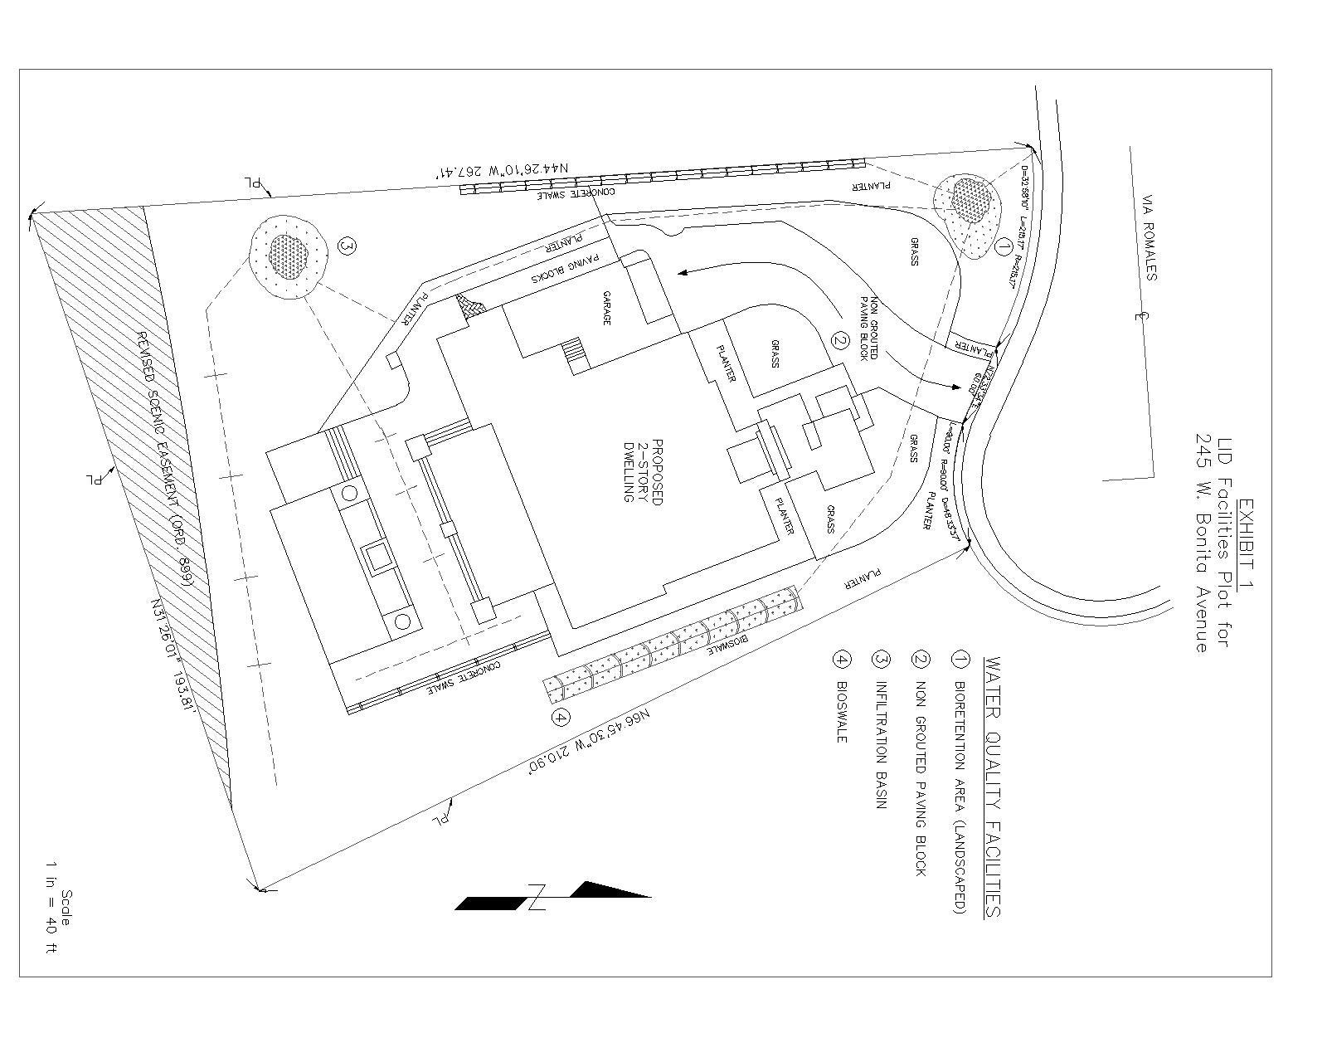

COVE
N
A
NT

A
N
D

A
G
RE
E
M
ENT

Project Owner’s Certification
Permit/Application No. |  | Grading Permit No.
Tract/Parcel Map No. |  | Building Permit No.
CUP, SUP, and/or APN (Specify Lot Numbers if Portions of Tract)
This Low Impact Development Plan (LID PLAN) has been prepared for Owner/Developer Name by Consulting/Engineering Firm Name. The LID PLAN is intended to comply with the requirements of the local NPDES Stormwater Program requiring the preparation of the plan.
The undersigned, while it owns the subject property, is responsible for the implementation of the provisions of this plan and will ensure that this plan is amended as appropriate to reflect up-to-date conditions on the site consistent with the current Waste Discharge Requirements and National Pollutant Discharge Elimination System (NPDES) Permit for Municipal Separate Storm Sewer System (MS4) Discharges within the Coastal Watersheds of Los Angeles, Permit No. CAS004004, Board Order R4-2021-0105 and the related current Los Angeles County Low Impact Development Standards Manual (LID Standards Manual). Once the undersigned transfers its interest in the property, its successors-in-interest shall bear the aforementioned responsibility to implement and amend this LID PLAN. An appropriate number of approved and signed copies of this document shall be available on the subject site in perpetuity.
Owner:
Title
Company
Address
Email
Telephone #
Signature |  | Date

Preparer (Engineer):
Title |  | PE Registration #
Company
Address
Email
Telephone #
I hereby certify that this Low Impact Development Plan is in compliance with, and meets the requirements set forth in, Order No. R4-2021-0105/NPDES No. CAS004004, of the Los Angeles Regional Water Quality Control Board.
Preparer Signature |  |  | Date
Place
Stamp
Here

TABLE OF CONTENTS
Section 1- Project Information 7
Section 2- LID Best Management Practices 12
Section 3- Alternative Compliance 15
Section 4- Hydromodification Control 19
Section 5- Source Control Best Management Practices 21
Section 6- Operation and Maintenance 23
Section 7- Site Plan and Drainage Plan 24

ATTACHMENTS
- Site Plan and Drainage Plan
- HydroCalc Outputs per DMA (or other City-approved modeling)
- Geotechnical Reports (including groundwater, soil and infiltration study information)
- LID BMP Design Details
- Technical Infeasibility Analysis (if applicable)
- Alternative Compliance Assessment/Documents
- Hydromodification Analysis
- Operation and Maintenance Plan
- Maintenance Covenant (Example Provided)
- Rainwater Harvesting Information (if applicable)

Section 1 Project Information

1.1 Project Description
Provide a detailed project description including:
- Project areas; Land uses; Land cover; Design elements
- A general description not broken down by drainage management areas (DMAs).
Include attributes relevant to determining applicable source controls. Refer to Section 2.1 in the LID Standards for information that must be included in the project description (LID Standards Manual is available for download at https://pw.lacounty.gov/wmd/dsp_LowImpactDevelopment.cfm.
Proposed Project Details (do not leave blank, use N/A if necessary)
Permit/Application No. |  |  | Tract/Parcel Map No.
Address of Project Site:
Project Category (List type of project Verbatim from LID Standards Plan Section 2.1)
Project Area (ft²): | Number of Dwelling Units: |  |  |  | SIC Code:
Narrative Project Description:
Project Area | Pervious |  |  | Impervious
Project Area | Area  (sq ft) | Percentage |  | Area  (sq ft) |  |  | Percentage
Pre-Project Conditions
Post-Project Conditions
Water Quality Conditions
(list verbatim)
Building Summary:
(Provide info. On Plans/Phases and total units)
Amenities:
Landscape Area Description:
Parking Facilities:
Other Project Features (i.e., trash enclosures, outdoor storage, car wash, commercial kitchen/food prep)
Outdoor Activities: (i.e., pool, community garden, dog park)
Materials Stored Outdoor (i.e., pool chemicals, equipment, etc.)
Wastes Generated: (provide info on wastes generated, i.e, from swimming pools and spas, trash, building maintenance)

1.2 Pollutants of Concern
Determine and list expected stormwater pollutants based on land uses, site activities, watershed management areas and 303(d) listed impairments.
Refer to Section 7 and Appendix B in the LID Standards Manual.
Pollutants of Concern
Pollutant | Applicability

1.3 Watershed Description
Fill out table with relevant information. Refer to Section 4 in the LID Standards Manual.
Receiving Waters
Applicable TMDLs or other 303d listed impairments
Environmentally Sensitive and Special Biological Significant Areas
Watershed Management Area

1.4 Site Characteristics
Fill out table with relevant information and include information regarding BMP sizing, suitability, and feasibility, as applicable. Refer to Section 4 and Section 6 in the LID Standards Manual.
Precipitation Zone
Topography
Existing Drainage Patterns/Connections
Soil Type, Geology, and Infiltration Properties
Hydrogeologic (Groundwater) Conditions
Geotechnical Conditions
Off-Site Drainage
Utility and Infrastructure Information

1.5 Post Development Drainage Characteristics
Describe post development drainage characteristics. How does on-site drainage connect off-site?

Section 2 LID Best Management Practices (BMPs)
2.1 LID Project Performance Criteria

Refer to Section 6 and Appendix E of the LID Standards Manual for guidance.

This project is required to control runoff from impervious surfaces through on-site infiltration, bioretention and/or rainfall harvest and use. As such, the Project is required to retain on-site the Storm Water Quality Design Volume (SWQDV). The SWQDV is defined as the greater of the following:

a) The runoff from the 0.75-inch, 24-hour rain event, or
b) The runoff from the 85th percentile, 24-hour rain event

The City of San Dimas’ 85th percentile, 24-hour rain event per the Los Angeles County’s Rain Gage Data and Isohyetal Map is 1.00 inch. The 85th percentile, 24-hour rain event (1.00-inch depth) governs.

Using the hydrologic calculator, HydroCalc³, program provided by the Los Angeles County Department of Public Works, provide the HydroCalc hydrograph output data per drainage area as Attachment B to this LID Plan and summarize bellow:

DMA Name or ID | SWQDV
DMA Name or ID | SWQDV

³ HydroCalc completes the full MODRAT calculation process and produces the peak stormwater runoff flow rates and volumes for single subareas. Because HydroCalc does not have reach routing capabilities, it is limited to watersheds and project areas up to 40 acres.

Download HydroCalc calculator at http://dpw.lacounty.gov/wrd/publication/

2.2 LID BMP Selection

Each sub-section below documents that the proposed design features conform to the applicable project performance criteria via check boxes, tables, calculations, narratives, and/or references to worksheets. Refer to Section 7 in the LID Standards Manual. Conform to the design specifications outlined in the Fact Sheets of Stormwater Quality Control Measures located in Appendix E of the LID Standards Manual.

Projects must design and implement stormwater quality control measures that can mitigate for the SWQDV and stormwater runoff in excess of this volume must be diverted around the stormwater quality control measures to prevent overloading.

The retention-based stormwater quality control measures in the LID Standards Manual are categorized into the following:
BMP Type | Fact Sheet
Bioretention | RET-1
Infiltration Basin¹ | RET-2
Infiltration Trench¹ | RET-3
Dry Well¹ | RET-4
Permeable Pavement without an Underdrain | RET-5
Rain Barrel/Cistern | RET-6

Please note: When evaluating the potential for on-site retention, each project shall consider the maximum potential for evapotranspiration from green roofs and rainfall harvest and use before alternative compliance can be considered. Provide this assessment as Attachment J to this LID Plan.

Identify the proposed LID Retention BMPs for this project
DMA NAME or ID | RETENTION LID BMPs |  |  | NO LID  (ALT. COMPLIANCE)
DMA NAME or ID | Infiltration | Bioretention | Harvest and Use | NO LID  (ALT. COMPLIANCE)

¹If an infiltration system is “deeper than its widest surface dimension,” or includes an assemblage of perforated pipes, drain tiles, or other similar mechanisms intended to distribute runoff below the surface of the ground, it would probably be considered a "Class V Injection Well" under the federal Underground Injection Control (UIC) Program, which is regulated in California by U.S. EPA Region 9. A UIC permit may be required for such a facility (for details see https://www.epa.gov/uic).

2.3 LID Project Conformance Analysis
Summarize how the SWQDV is being met with retention BMPs and provide detailed design calculations as Attachment D to this LID Plan. If the SWQDV cannot be met with retention BMPs, document how much can be met and provide justification why the design volume cannot be fully met with retention BMPs. Additionally, describe the proposed path towards compliance. As described in Section 3, provide the project’s Technical Infeasibility Analysis as Attachment E to this LID Plan.

Section 3 Alternative Compliance

3.1 Technical Infeasibility Analysis
In instances of technical infeasibility or where your project has been determined to provide an opportunity to replenish regional ground water supplies at an offsite location within the same sub-watershed (HUC-12) as the new development or redevelopment project, MS4 Permit compliance may be obtained through alternative compliance measures.

To demonstrate technical infeasibility, the project applicant must demonstrate that the project cannot reliably retain 100 percent of the SWQDV on-site, even with the maximum application of green roofs and rainwater harvest and use, and that compliance with the applicable post-construction requirements would be technically infeasible by submitting a site-specific hydrologic and/or design analysis conducted and endorsed by a registered professional engineer, geologist, architect, and/or landscape architect. Provide the project’s Technical Infeasibility Analysis as Attachment F to this LID Plan.
Technical infeasibility may result from conditions including the following:
(a) The infiltration rate of saturated in-situ soils is less than 0.3 inch per hour and it is not technically feasible to amend the in-situ soils to attain an infiltration rate necessary to achieve reliable performance of infiltration or bioretention BMPs in retaining the SWQDV on-site.
(b) Locations where seasonal high ground water is within 5 to 10 feet of the surface.
(c) Locations within 100 feet of a ground water well used for drinking water.
(d) Brownfield development sites where infiltration poses a risk of causing pollutant mobilization.
(e) Other locations where pollutant mobilization is a documented concern.54
(f) Locations with potential geotechnical hazards.
(g) Smart growth and infill or redevelopment locations where the density and/or nature of the project would create significant difficulty for compliance with the on-site volume retention requirement.

Describe an alternative compliance plan (if applicable). Include technical infeasibility justification and describe proposed alternative compliance measures. Refer to Section 7.4 in the LID Standards Manual for guidance.

3.2 Off-Site Ground Water Replenishment Opportunities
To utilize alternative compliance measures to replenish ground water at an offsite location, the project applicant shall demonstrate:
(a) Why it is not advantageous to replenish ground water at the project site,
(b) That the offsite location is in the same sub-watershed (HUC-12) as the Development Project,
(c) That ground water can be used for beneficial purposes at the offsite location, and
(d) That the alternative measures shall also provide equal or greater water quality benefits to the receiving surface water than the LID Project Performance Criteria outlined in Section 2

If applicable, provide a summary justification below and thorough supporting documentation in Attachment F to this LID Plan.

3.3 On-Site Biofiltration BMPs
If the full Design Storm Capture Volume cannot be met with retention BMPs and project has provided information demonstrating technical infeasibility, describe proposed on-site Biofiltration (BIO-1) BMPs. Provide design details in Attachment F to this LID Plan.
- Biofiltration BMPs must be sized to capture and treat 1.5 times the portion of the SWQDV that is not reliably retained on-site.)
  - B_{v} = 1.5(SWQDV – R_{v}) where R_{v} = volume reliably retained onsite and B_{v} is the biofiltration volume

- Biofiltration systems shall, at a minimum, meet design specifications consistent with those provided in the Los Angeles County LID Standards Manual.

- Biofiltration systems discharging to a receiving water that is included on the Clean Water Act section 303(d) list of water quality-limited (i.e., impaired) water bodies due to nitrogen compounds or related effects shall be designed and maintained to achieve enhanced nitrogen removal capacity.

3.4 Off-Site Alternative Compliance
On-site biofiltration is the preferred alternative compliance measure. If it is determined that on-site biofiltration is technically infeasible, the following off-site alternative compliance measures may be considered:
- Off-site Infiltration
  - Projects may use infiltration or bioretention BMPs to intercept a volume of stormwater runoff equal to the SWQDV, less the volume of stormwater runoff reliably retained onsite, at an approved offsite project located within the same subwatershed (HUC-12) as the Priority Development Project, and provide pollutant reduction (treatment) of the stormwater runoff discharged from the project site in accordance with the Water Quality Mitigation Criteria provided in Part VIII.F.4.d of this Order. The required offsite mitigation
  - Volume (Mv) shall be calculated by the equation: M_{v} = SWQDV - R_{v}
(where R_{v} = volume reliably retained onsite)

- Off-site Project - Retrofit Exiting Development
  - Contact the City for permissions to propose this path of compliance.

3.4 On-Site Flow Based BMPs
If it is determined that on-site biofiltration and off-site alternative compliance measures are not technically feasible, the City may request the Executive Officer of the Regional Water Quality Control Board to allow the use of on-site flow-based BMPs. In the request, the City must outline why none of the other alternative compliance measures are feasible. Approval will only be granted to areas where other alternative compliance measures are not feasible due to significant technical issues.

If approved, the City may allow the Priority Development Project to utilize flow-through treatment control BMPs to treat runoff leaving the site, and mitigate for the design capture volume not reliably retained onsite.

Flow-through treatment control BMPs must be sized and designed to:

(a) Filter or treat either:
(1) The maximum flow rate of runoff produced from a rainfall intensity of 0.2 inch of rainfall per hour, for each hour of a storm event; or
  - (2) The maximum flow rate of runoff produced by the 85th percentile hourly rainfall intensity (for each hour of a storm event), as determined from the local historical rainfall record, multiplied by a factor of two;

  - (b) Be certified for “Enhanced Treatment” under the Washington State Department of Ecology’s TAPE Program; or an appropriate future BMP certification developed by the State of California.

  - A formal letter must be provided to the City that demonstrates the aforementioned criteria for use of on-site flow based BMPs. The City will submit to the Regional Board on behalf of the Priority Development Project.

Section 4 Hydromodification
Once you have determined that the LID design is adequate to address LID water quality requirements, you will need to assess if the proposed project may still need to implement hydrological control measures to prevent accelerated downstream erosion and protect stream habitat.
4.1 Hydromodification Exemptions
The City may exempt the following projects from implementation of hydromodification controls where assessments of downstream channel conditions and proposed discharge hydrology indicate that adverse hydromodification effects to beneficial uses of Natural Drainage Systems are unlikely:
- Projects that are replacement, maintenance or repair of a Permittee’s existing flood control facility, storm drain, or transportation network.
- Redevelopment Projects in the Urban Core that do not increase the effective impervious area or decrease the infiltration capacity of pervious areas compared to the pre-project conditions.
- Projects that have any increased discharge directly or via a storm drain to a sump, lake, area under tidal influence, into a waterway that has a 100-year peak flow (Q100) of 25,000 cfs or more, or other receiving water that is not susceptible to hydromodification impacts.
- Projects that discharge directly or via a storm drain into concrete or otherwise engineered (not natural) channels (e.g., channelized or armored with rip rap, shotcrete, etc.), which, in turn, discharge into receiving water that is not susceptible to hydromodification impacts (as in Parts VIII.F.2.b.i-iii above).
- LID BMPs implemented on single family homes are sufficient to comply with Hydromodification criteria.
- Projects disturbing an area less than one acre.

Is your project exempt from implementing hydromodification controls?

No Yes – Provide exemption number from above and proceed to Section 5

4.2 Hydromodification BMP Selection and Project Conformance Analysis

If none of the HCOC Exemption Criteria are applicable, hydromodification criteria is considered mitigated if the projects meets one of the following conditions:
  - 1. Projects disturbing an area greater than 1 acre, but less than 50 acres will be presumed to meet pre-development hydrology if one of the following demonstrations are made:
  - (a) The project is designed to retain onsite the runoff of the 95th percentile, 24-hour storm; or
  - (b) The runoff flow rate, volume, velocity, and duration for the post-development condition do not exceed the pre-development condition for the 2-year, 24-hour storm event. This condition may be substantiated by simple screening models, including those described in Hydromodification Effects on Flow Peaks and Durations in Southern California Urbanizing Watersheds or other models acceptable to the Executive Officer of the Los Angeles Water Board; or

  - (c) The Erosion Potential (Ep) in the receiving water is approximately 1.

  - OR

- 2. Projects disturbing 50 acres or more will be presumed to meet pre-development hydrology based on the successful demonstration of one of the following conditions:

  - (a) The site infiltrates onsite the runoff from a 2-year, 24-hour storm event; or
  - (b) The runoff flow rate, volume, velocity, and duration for the post-development condition does not exceed the pre-development condition for the 2-year, 24-hour storm event. These conditions must be substantiated by hydrologic modeling acceptable to the Los Angeles Water Board Executive Officer; or
  - (c) The Erosion Potential (Ep) in the receiving water is approximately 1.

Describe the proposed hydromodification control BMPs. See Section 8 of LID Standards Manual for Guidance. Include sections for selection, suitability, sizing, and infeasibility, as applicable. Detail compliance with Prior Conditions of Approval. Be sure to include all pertinent documentation used in your analysis of the items a, b or c in Attachment G to this LID Plan.
Section 5 Source Control BMPs
Provide description of the nonstructural and structural source control measures to be included in the project or provide a brief narrative explaining if source control measure was not used. Include a copy of the applicable fact sheets in the appendix. Fact Sheets can be found in the California Stormwater Best Management Practices Handbooks available at www.casqa.org.

See Section 5 and Table 5-1 in the LID Standards Manual for selection of required source control measures.

NON-STRUCTURAL SOURCE CONTROL BMPS
Identifier | Name | Included  Y/N/NA | Brief Description of source control measure to be implemented or explanation as to why it is not used.
SC-10 | Non-Stormwater Discharges
SC-11 | Spill Prevention, Control and Cleanup
SC-20 | Vehicle and Equipment Fueling
SC-21 | Vehicle and Equipment Cleaning
SC-22 | Vehicle and Equipment Repair
SC-30 | Outdoor Loading/Unloading
SC-31 | Outdoor Liquid Container Storage
SC-32 | Outdoor Equipment Operations
SC-33 | Outdoor Storage of Raw Materials
SC-34 | Waste Handling and Disposal
SC-40 | Contamination of Erodible Areas
SC-41 | Building and Grounds Maintenance
SC-42 | Building and Repair and Construction
SC-43 | Parking/Storage Area
SC-44 | Drainage System Maintenance
OTHER | List:

STRUCTURAL SOURCE CONTROL BMPS
Identifier | Name
Identifier | Name | Included  Y/N/NA | Brief Description of source control measure to be implemented or explanation as to why it is not used.
S1 | Storm Drain Message and Signage
S2 | Outdoor Material Storage Area Design
S3 | Outdoor Trash Storage and Waste Handling Area Design
S4 | Outdoor Loading/Unloading Dock Area Design
S5 | Outdoor Repair/Maintenance Bay Design
S6 | Outdoor Vehicle, Equipment, Accessory Washing Area Design
S7 | Fueling Area Design
S8 | Proof of Control Measure Maintenance
S9 | Building Materials
S10 | Animal Care and Handling Facilities
S11 | Outdoor Horticulture Areas
SD10 | Site Design and Landscape Planning
SD11 | Roof Runoff Controls
SD-12 | Efficient Irrigation
SD-13 | Storm Drain Signage
SD-20 | Pervious Pavements
SD-30 | Fueling Areas
SD-31 | Maintenance Bays and Docks
SD-32 | Trash Enclosures
SD-33 | Vehicle Washing Areas
SD-34 | Outdoor Material Storage Areas
SD-35 | Outdoor Work Areas
SD-36 | Outdoor Processing Areas
 | Other BMP______________________

Section 6 Operation and Maintenance

Property Ownership/Management
Describe property ownership/management. Include contact information.

Prepare and provide an Operation and Maintenance Plan as Attachment H to this LID Plan. Refer to Section 9 of the LID Standards Manual for criteria required to be included in the O&M Plan
Prepare and provide a copy of the Maintenance Covenant that is to be recorded at the County Recorder’s office as Attachment I to this LID Plan. Ensure the City of San Dimas specific maintenance covenant is used.

Section 7 Site Plan and Drainage Plan
Include a site plan and drainage plan sheet set that contains the following minimum information as Attachment A to this LID Plan:
- Project location
- Site boundary
- Land uses and land covers, as applicable
- Structural BMP locations
- Drainage area delineations
- Flow information (e.g. flow arrows)
- Drainage connections
- BMP details

Attachment A

Attachment B

Attachment C

Attachment D

Attachment E

Attachment F

Attachment G

Attachment H

Attachment I
Example Maintenance Covenant
Attachment J

It may be technically infeasible for stormwater runoff harvest and use for the following
situations:

- Projects that would not provide sufficient irrigation or (where permitted) domestic grey water demand for use of stored stormwater runoff due to limited landscaping or extensive use of low water use plant palettes in landscaped areas;
- Projects that are required to use recycled water for landscape irrigation;
- Projects in which the harvest and use of stormwater runoff would conflict with local, state, or federal ordinances or building codes;
- Locations where storage facilities may cause potential geotechnical hazards as outlined in the geotechnical report; or
- Locations where storage facilities may cause health and safety concerns.

Provide Infeasibilitiy Criteria

**If deemed feasible, attach feasibility analysis

